** **

**From Pixels to Planks-**

**Deep Learning for Wood Texture Generation**

Project Hand-Out

-Prince Singh

**From Pixels to Planks: Deep Learning for Wood Texture Generation**

Wood has been an essential material in various industries, ranging from construction to furniture manufacturing. The unique patterns and textures found in different types of wood have long captivated human imagination. However, replicating these intricate wood textures manually can be time-consuming and challenging.In recent years, deep learning techniques have emerged as powerful tools for generating realistic and customizable textures. Leveraging the capabilities of deep neural networks, researchers and developers have explored the application of deep learning in wood texture generation, aiming to mimic the complexity and diversity found in natural wood.

This project, titled "From Pixels to Planks: Deep Learning for Wood Texture Generation," presents a novel approach to generate wood textures using deep learning algorithms. By training a generator and discriminator model, this project enables the generation of various wood textures by inputting the desired number of images to be created. The generated textures possess the characteristics and intricate details reminiscent of real wood grains and patterns.

The integration of deep learning with wood texture generation offers numerous practical applications. Industries such as architecture, interior design, and digital entertainment can benefit from a readily available source of customizable and realistic wood textures. This project aims to contribute to the growing field of computer-generated imagery by providing a powerful tool for generating high-quality wood textures in a time-efficient manner.

**Aim:**

**The aim of this project is to develop a deep learning model, consisting of a generator and discriminator, for generating diverse wood textures based on user-defined parameters. The project further aims to deploy the trained model using Flask, enabling users to interactively generate and explore customizable wood textures through a web interface.**

**Purpose of doing this Project:**

The purpose of undertaking this deep learning project on wood texture generation is to leverage the capabilities of machine learning algorithms to automate and enhance the process of generating diverse and realistic wood textures. By developing a system that takes the desired number of images as input, the project aims to create a user-friendly interface where users can effortlessly generate a wide range of wood textures customized to their specific needs. The deployment of the model using Flask allows for easy access and interaction, making the generated wood textures accessible to various industries, such as architecture, interior design, and digital entertainment. Ultimately, the project seeks to provide a practical and efficient solution for wood texture generation, reducing manual effort and unlocking creative possibilities.

**Technical Architecture:**

The wood texture generation project follows a technical architecture that combines deep learning techniques and web development using Flask. The project utilizes a generator and discriminator, which are key components of a Generative Adversarial Network (GAN). The generator takes the desired number of images as input and generates wood textures, while the discriminator evaluates the authenticity of the generated textures. The trained model is saved in a .pth file format. To deploy the model, Flask, a Python web framework, is used to create a web interface. Users can interact with the deployed model through the web interface, inputting parameters and obtaining the generated wood textures in real-time, providing a seamless and user-friendly experience.

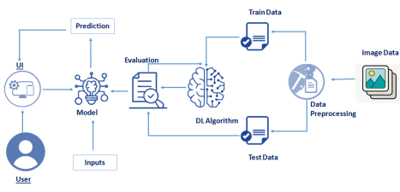

**Pre requisites:**

**To complete this project, you must require following software’s , concepts and packages**

* **Anaconda navigator:**

- Refer to the link below to download anaconda navigator

- Link : https://www.youtube.com/watch?v=5mDYijMfSzs

* Python packages:

- Open anaconda prompt as administrator

- Type “pip install tensorflow” (make sure you are working on python 64 bit)

- Type “pip install flask”.

* **Deep Learning Concepts**

- CNN: https://towardsdatascience.com/basics-of-the-classic-cnn-a3dce1225add

- Flask Basics : https://www.youtube.com/watch?v=lj4I_CvBnt0

**Project Objectives:**

By the end of this project you will:

* Know fundamental concepts and techniques of Convolutional Neural Network.
* Gain a broad understanding of image data.
* Knowhow to pre-process/clean the data using different data preprocessing techniques.
* Know how to build a web application using Flask framework.

**Project Flow:**

* User interacts with the UI (User Interface) to upload the image as input
* Uploaded image is analyzed by the model which is integrated
* Once model analyzes the uploaded image, the prediction food recipe is showcased on the UI to accomplish this, we have to complete all the activities and tasks listed below

o Data Collection.

o Collect the dataset or Create the dataset

o Data Preprocessing.

o Import the ImageDataGenerator library

o Configure ImageDataGenerator class

o Apply ImageDataGenerator functionality to Train set and Test set

o Model Building

o Import the model building Libraries

o Initializing the model

o Adding Input Layer

o Adding Hidden Layer

o Adding Output Layer

o Configure the Learning Process

o Training the model

o Save the Model

o Test the Model

o Application Building

o Create an HTML file

o Build Python Code

\

**Project Structure:**

Create project folder which contains files as shown below:

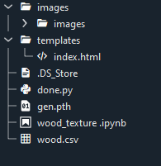

* The data obtained 8 folders containing 200 images of respective type of mango each, which is used one for training, testing, validation dataset.
* We are building a Flask application which will require the html files to be stored in the templates folder.
* app.py file is used for routing purposes using scripting.
* mango_classification_model.h5 is the saved model. This will further be used in the Flask integration.
* Whenever we upload an image to predict, that images is saved in uploads folder.

**Milestone 1: Define Problem/ Problem Understanding**

**Activity 1: Specify the Business Problem**

The business problem addressed by this deep learning project is the inefficiency and labor-intensive nature of manual wood texture generation. Traditional methods of replicating diverse wood textures require significant time and effort. By developing a deep learning-based solution that utilizes a generator and discriminator model, and deploying it using Flask, the project aims to provide businesses with an automated and customizable approach to generate high-quality wood textures, saving time, resources, and improving productivity.

**Activity 2: Business Requirements**

1. **Flask Deployment:** The system should be deployed using Flask, a web framework for Python. The deployment should provide a user-friendly web interface where users can interact with the model, input parameters, and obtain the generated wood textures.
2. **Performance:** The project should strive for efficient and timely generation of wood textures to ensure a smooth user experience and enhance productivity.
3. **Compatibility:** The deployed system should be compatible with different web browsers and devices, ensuring accessibility for a wide range of users.
4. **Scalability:** The system should be designed to handle varying workloads and scale appropriately to accommodate a growing number of user requests for wood texture generation.
5. **Reliability:** The system should be robust and reliable, ensuring consistent and accurate generation of wood textures, with minimal errors or inconsistencies.
6. **Trust:** The model should be designed in such a way that it develops trust among the users, especially the advertisers and content creators, who rely on the predicted adviews for their marketing strategies.\
7. **User-friendly interface:** The model should have a user-friendly interface to make it easy for users to input relevant metrics and obtain an estimated number of adviews.

**Activity 3: Literature Survey**

The literature survey for this deep learning project on wood texture generation reveals a growing interest in the application of generative models for texture synthesis. Previous studies have explored the use of Generative Adversarial Networks (GANs) to generate realistic textures, including wood textures. Researchers have investigated various architectures and training techniques to improve the quality and diversity of generated textures. Additionally, the deployment of deep learning models using frameworks like Flask has been explored to provide accessible and interactive interfaces for users to generate and customize textures.

**Activity 4: Social or Business Impact.**

**Social Impact:**

The deep learning project on wood texture generation has a positive social impact by offering a time-efficient and accessible solution for generating diverse wood textures. It empowers professionals in industries such as architecture and design, enabling them to create visually appealing and realistic wood textures easily. This improves productivity, creativity, and fosters innovation in related fields.

**Business Impact:**

The deep learning project on wood texture generation has significant business impact by streamlining the process of obtaining high-quality wood textures. It reduces manual effort and saves time, enabling businesses in industries such as architecture, interior design, and digital entertainment to enhance their workflows, improve product visualization, and meet client demands more efficiently, resulting in increased productivity and customer satisfaction.

**Milestone 2: Data Collection**

Machine Learning & Deep Learning depends heavily on data. It is the most crucial part aspect that makes algorithm training possible. So, this section guides on how to download dataset.

**Activity 1: Collect the dataset**

There are many popular open sources for collecting the data. Eg: kaggle.com, UCI repository, etc.

In this project we have used .csv data. This data is downloaded from kaggle.com. Please refer to the link given below to download the dataset.

Link: https://www.kaggle.com/datasets/wood _texture

As the dataset is downloaded. Let us read and understand the data properly with the help of some visualization techniques and some analyzing techniques.

**Note:** There are a number of techniques for understanding the data. But here we have used some of it. In an additional way, you can use multiple techniques.

**Milestone 3: Image Preprocessing**

**Importing libraries and setting value of manualseed**

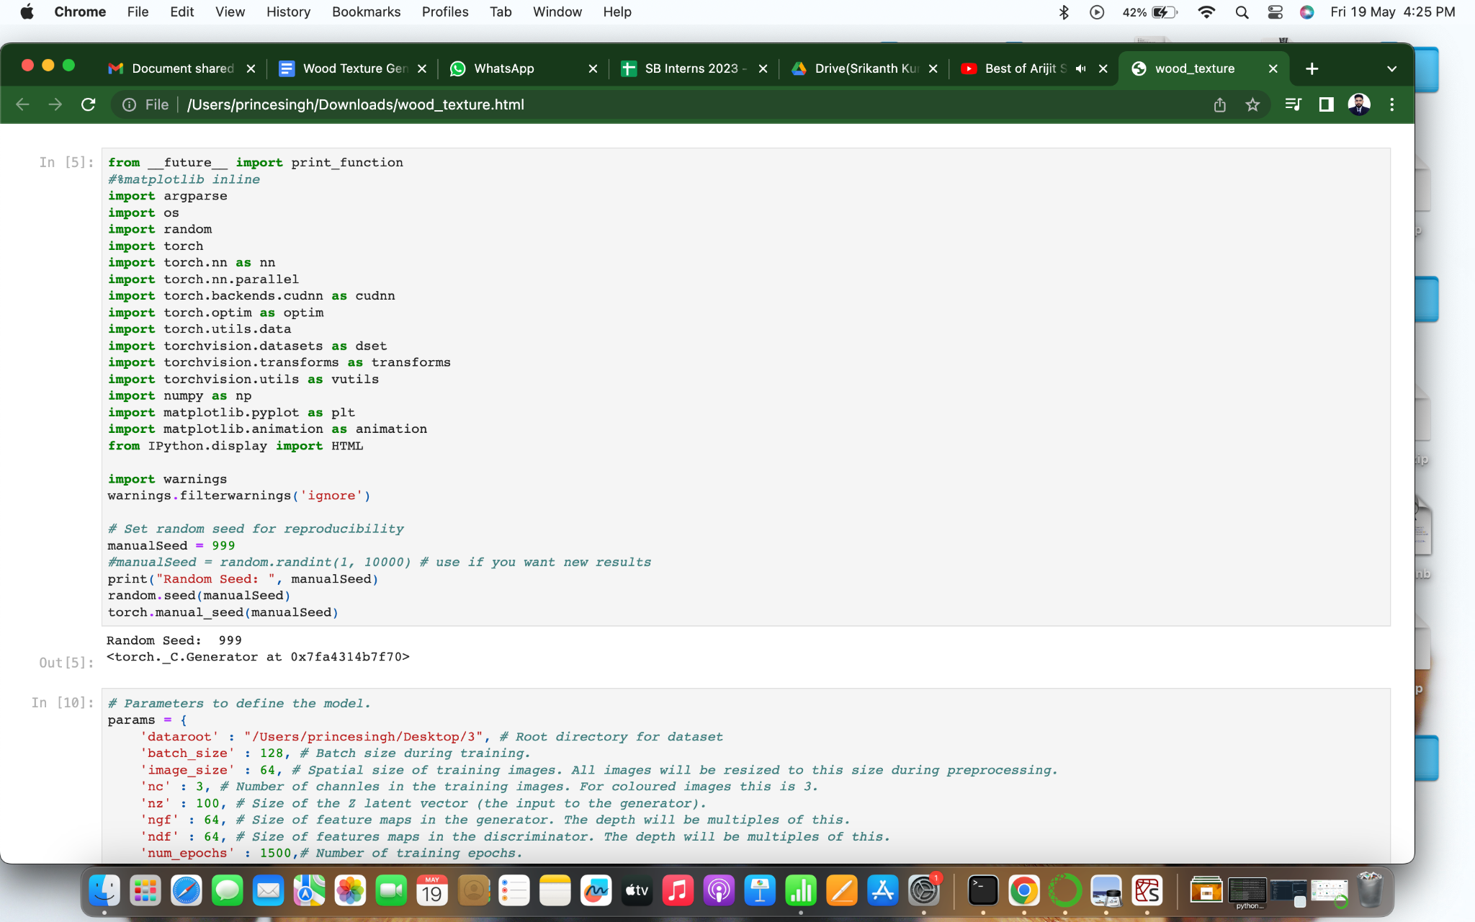

**Defining parameters, loading dataset:**

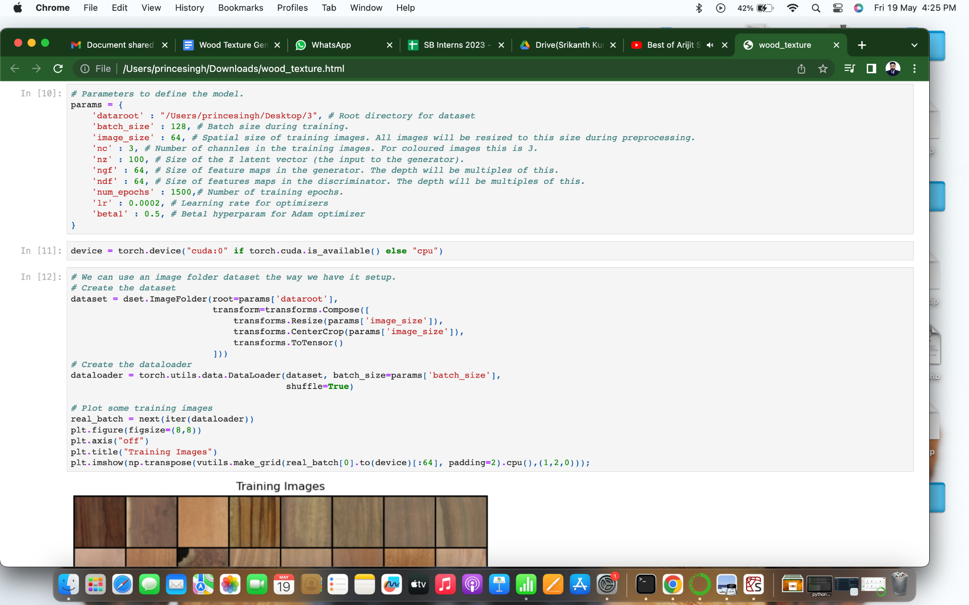

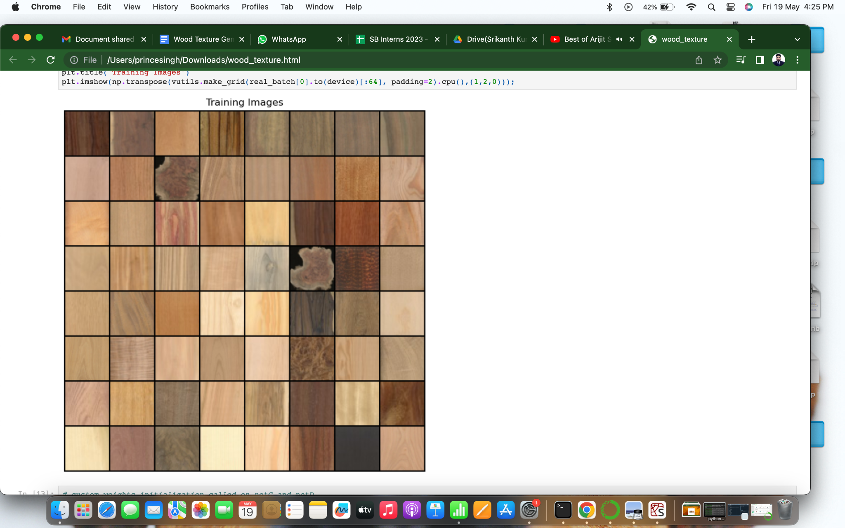

**Initializing weights for conv and Batchnorm cases:**

This Python code defines a function called weights_init that is used to initialize the weights of the generator (netG) and discriminator (netD). The function takes a module (m) as input and checks its class name. If the class name contains the substring 'Conv', it initializes the weights of the module's weight data with random values drawn from a normal distribution with a mean of 0.0 and a standard deviation of 0.02. If the class name contains the substring 'BatchNorm', it initializes the weights of the module's weight data with random values drawn from a normal distribution with a mean of 1.0 and a standard deviation of 0.02. Additionally, it sets the module's bias data to 0.

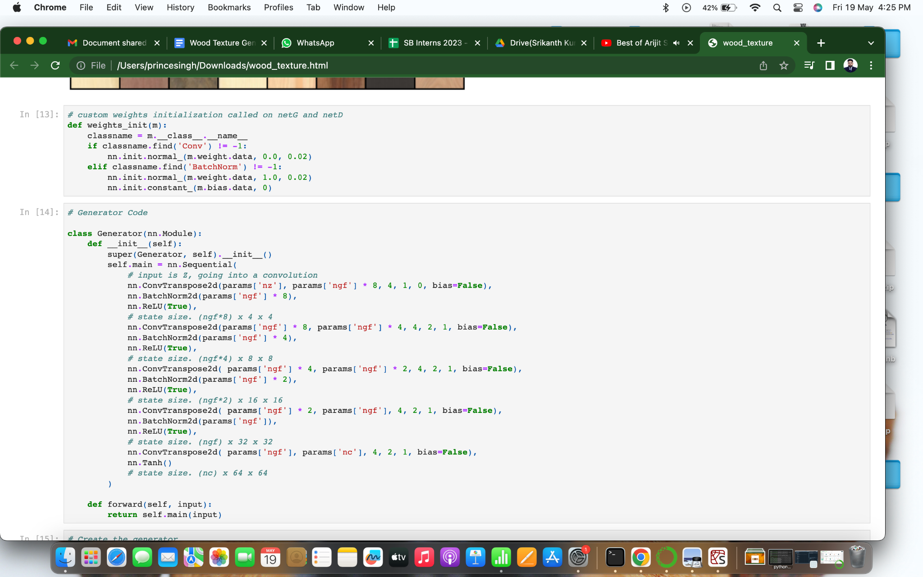

**Creating generator function:**

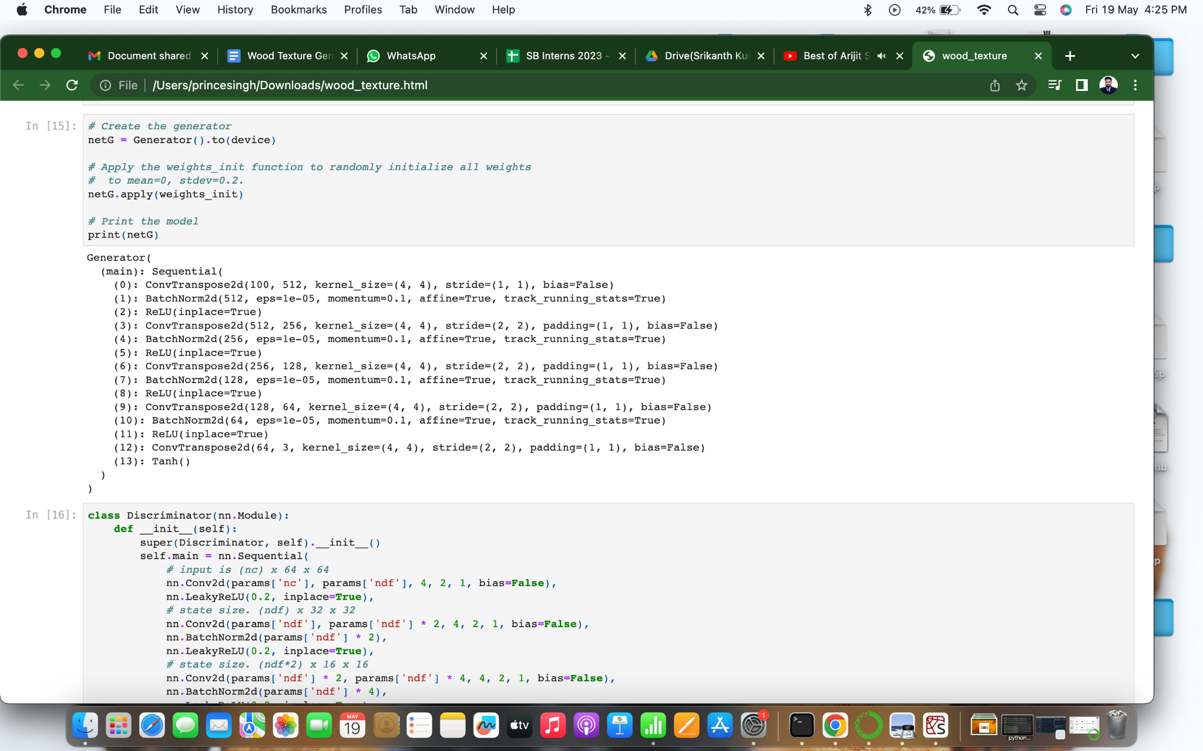

**Defining discriminator function:**

The nn.BCELoss() function is initialized. BCELoss stands for Binary Cross Entropy Loss and is commonly used as a loss function in binary classification problems. A batch of latent vectors called fixed_noise is created. These vectors will be used to visualize the progression of the generator during training. The size of the batch is 64, and each latent vector has a size of params['nz'] with dimensions of 1x1. The torch.randn() function is used to generate random values from a standard normal distribution. Two variables real_label and fake_label are established to represent the labels for real and fake samples, respectively. These labels are used during the training process to distinguish between real and generated/fake samples. Adam optimizers are set up for both the discriminator (netD) and the generator (netG). Adam is an optimization algorithm commonly used for training neural networks. The optimizer for the discriminator is initialized with the parameters of netD and a learning rate (lr) of params['lr']. The betas argument sets the coefficients for the exponential moving averages of the gradient and its square. Similarly, the optimizer for the generator is initialized with the parameters of netG and the same learning rate and beta values. These steps prepare the necessary components for training a generative adversarial network (GAN) for wood texture generation. The BCELoss function serves as the criterion for optimizing the GAN, and Adam optimizers are used to update the parameters of the discriminator and generator networks during training.

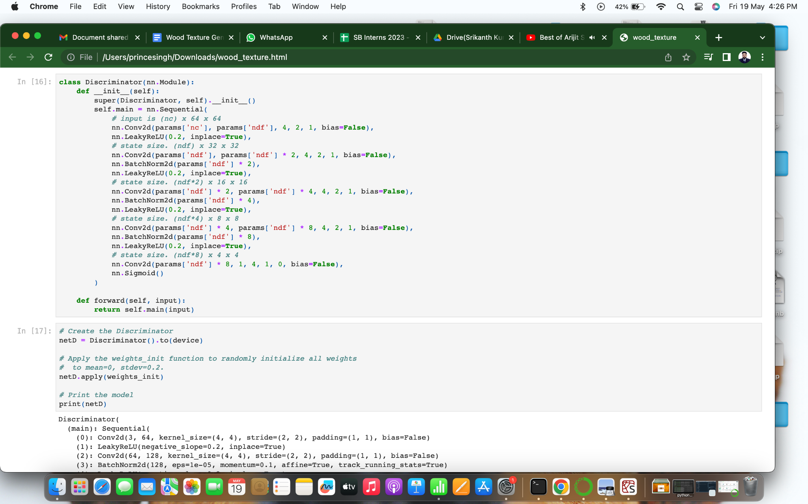

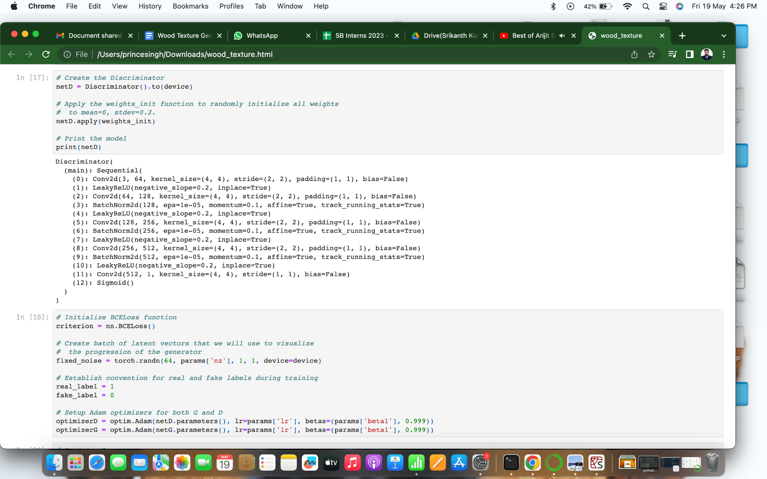

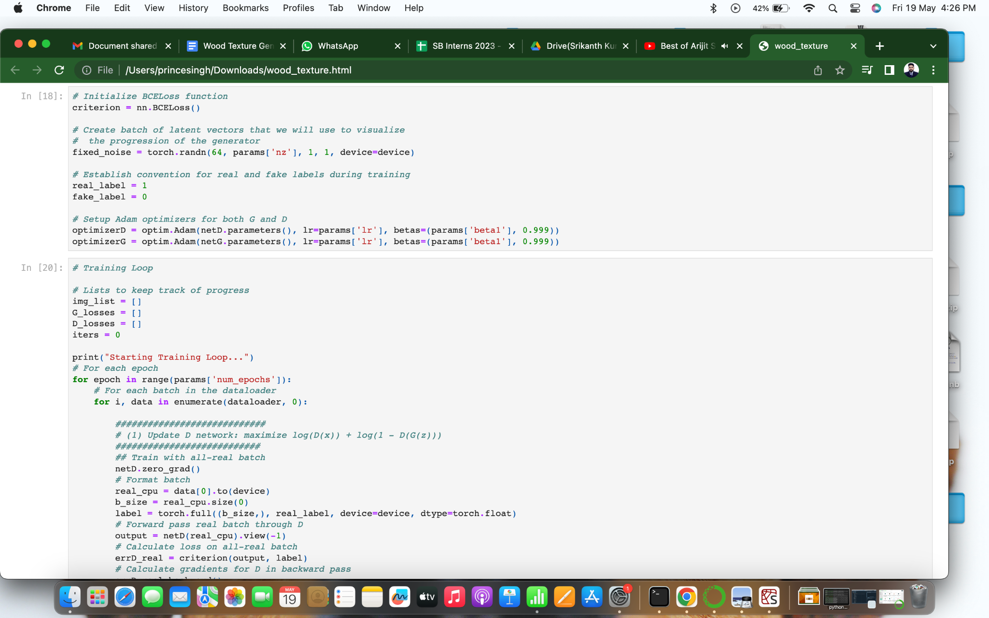

**Training the model:**

This Python code is a training loop for a deep learning project that aims to generate wood textures using a generative adversarial network (GAN). The code begins by initializing empty lists to track the progress of the training, including image samples, generator losses (G_losses), discriminator losses (D_losses), and the number of iterations (iters). The training loop consists of two main parts: Update the Discriminator (D) network: For each batch of real images, the discriminator is trained to classify them as real. The real images are passed through the discriminator (netD), and the output is compared with the true labels (label) using a loss function (criterion). The loss (errD_real) is calculated, and the gradients are computed and applied to update the discriminator's parameters. For each batch of generated (fake) images, the discriminator is trained to classify them as fake. The generator (netG) generates a batch of fake images by sampling from a latent space (noise). The fake images are passed through the discriminator, and the output is compared with the fake labels (label) using the loss function. The loss (errD_fake) is calculated, and the gradients are computed and applied to update the discriminator's parameters. The total discriminator loss (errD) is the sum of the losses from real and fake batches. The discriminator parameters are updated using an optimizer (optimizerD). Update the Generator (G) network: The generator is trained to generate images that can fool the discriminator into classifying them as real. The generator's parameters (netG) are updated by: Clearing the gradients. Setting the labels to real labels (label). Passing the generated images through the discriminator and calculating the loss (errG) based on the output and the real labels. Computing and applying the gradients to update the generator's parameters using an optimizer (optimizerG). During training, the losses for both the generator and discriminator are saved in the lists G_losses and D_losses, respectively. Additionally, the code periodically prints the training statistics, including the current epoch, iteration, discriminator loss (Loss_D), generator loss (Loss_G), and the discriminator's output on real (D(x)) and generated (D(G(z))) images. The code also saves image samples generated by the generator on a fixed set of noise vectors (fixed_noise) for visualization. These samples are appended to the img_list for later plotting. Overall, this code implements a GAN training loop for generating wood textures, updating the discriminator and generator alternately to optimize their performance.

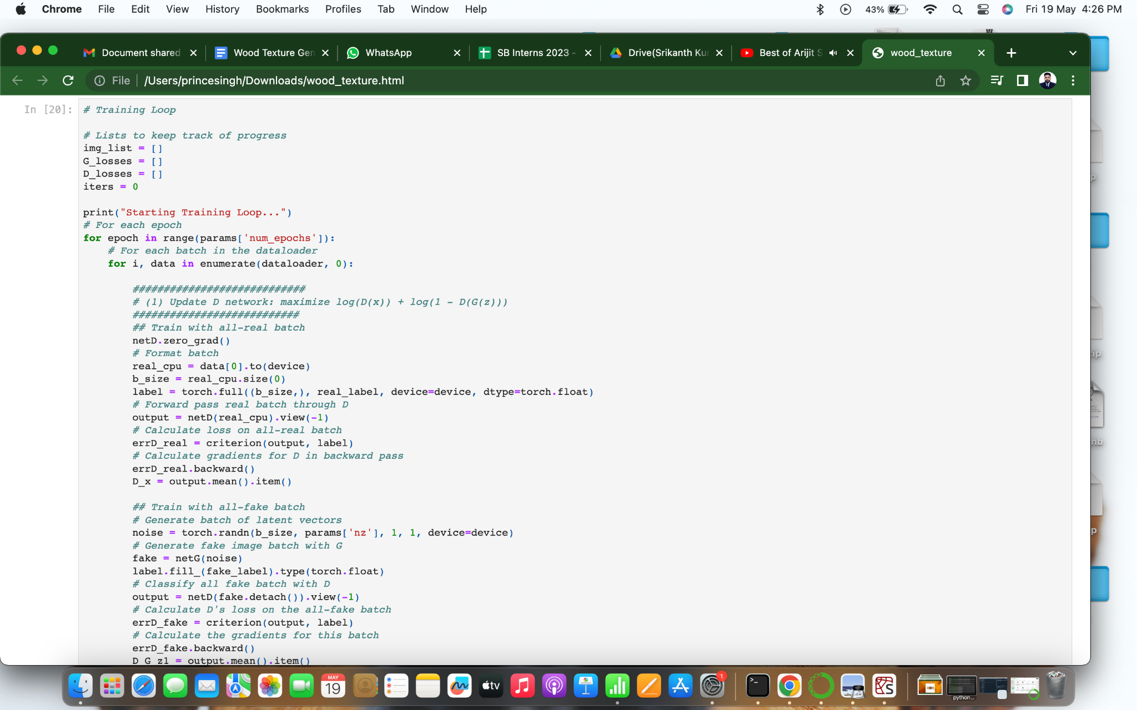

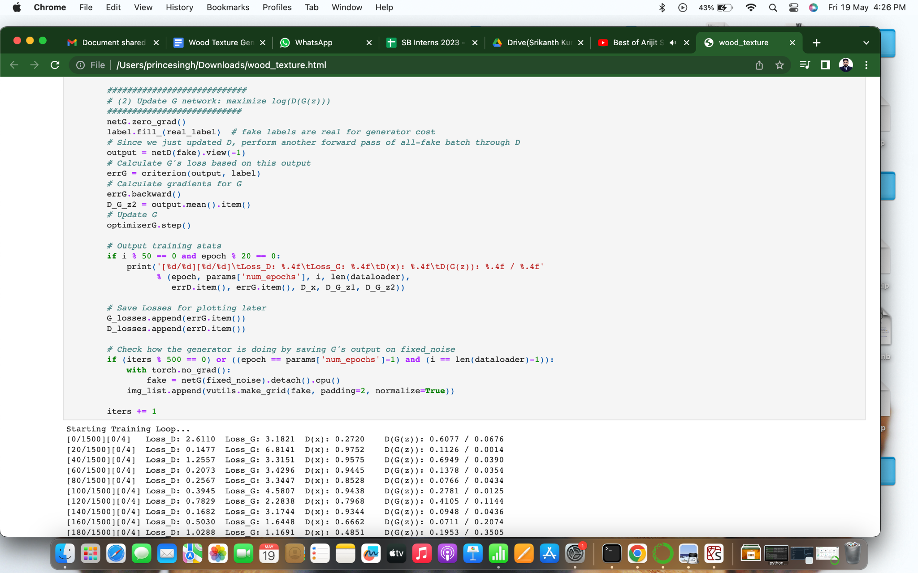

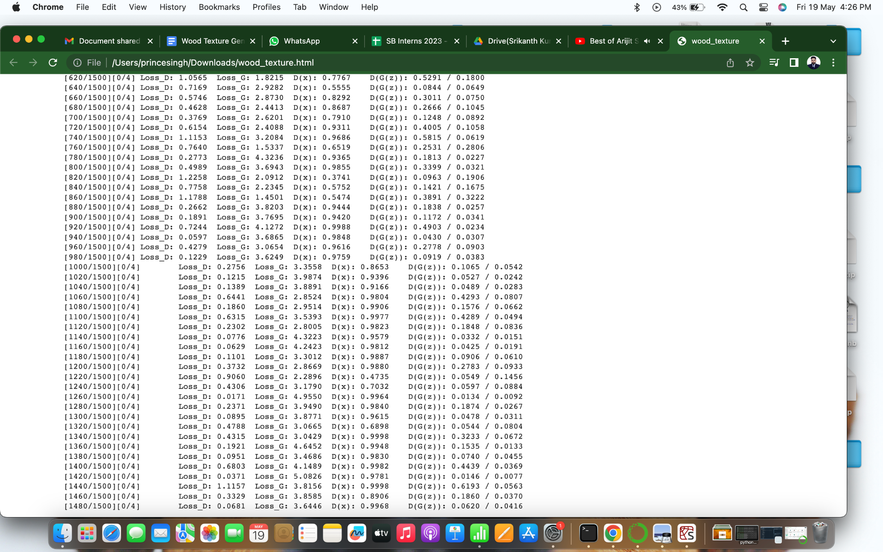

**Plotting individual generator and discriminator losses:**

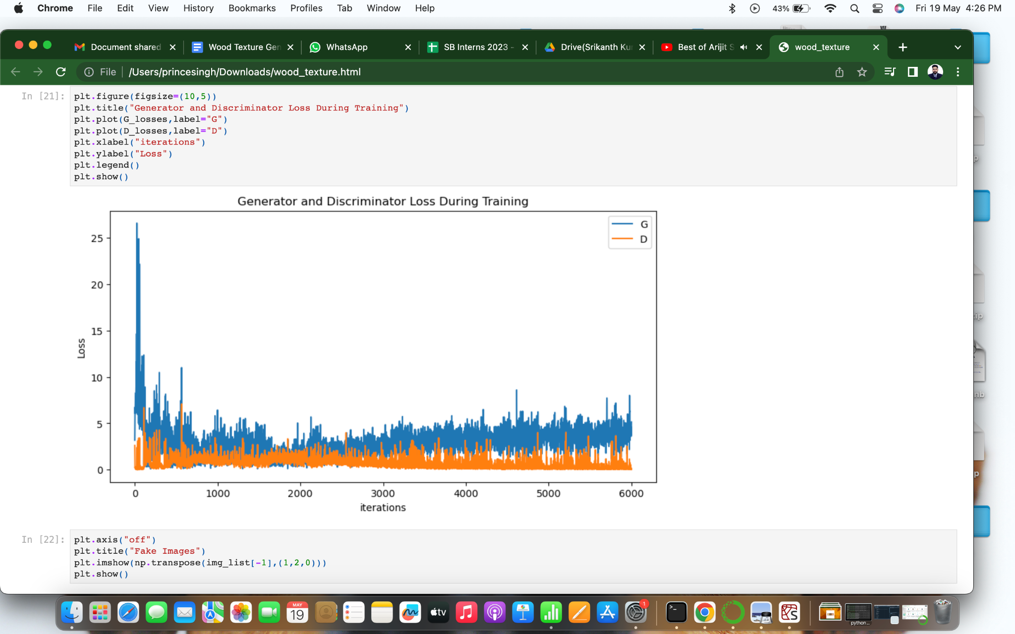

**Printing some generated wood textures by the model and saving the best model:**

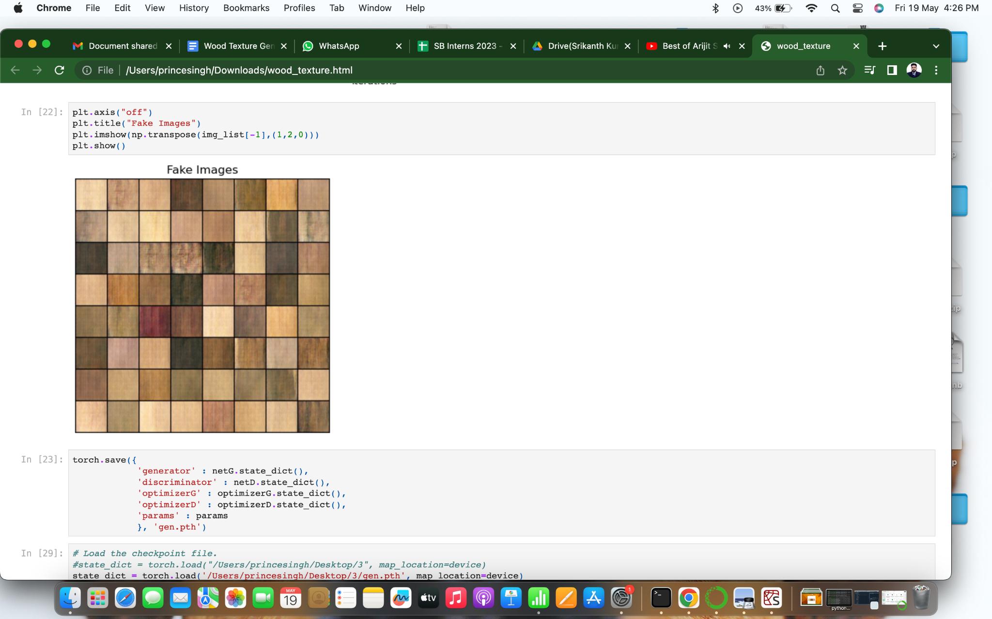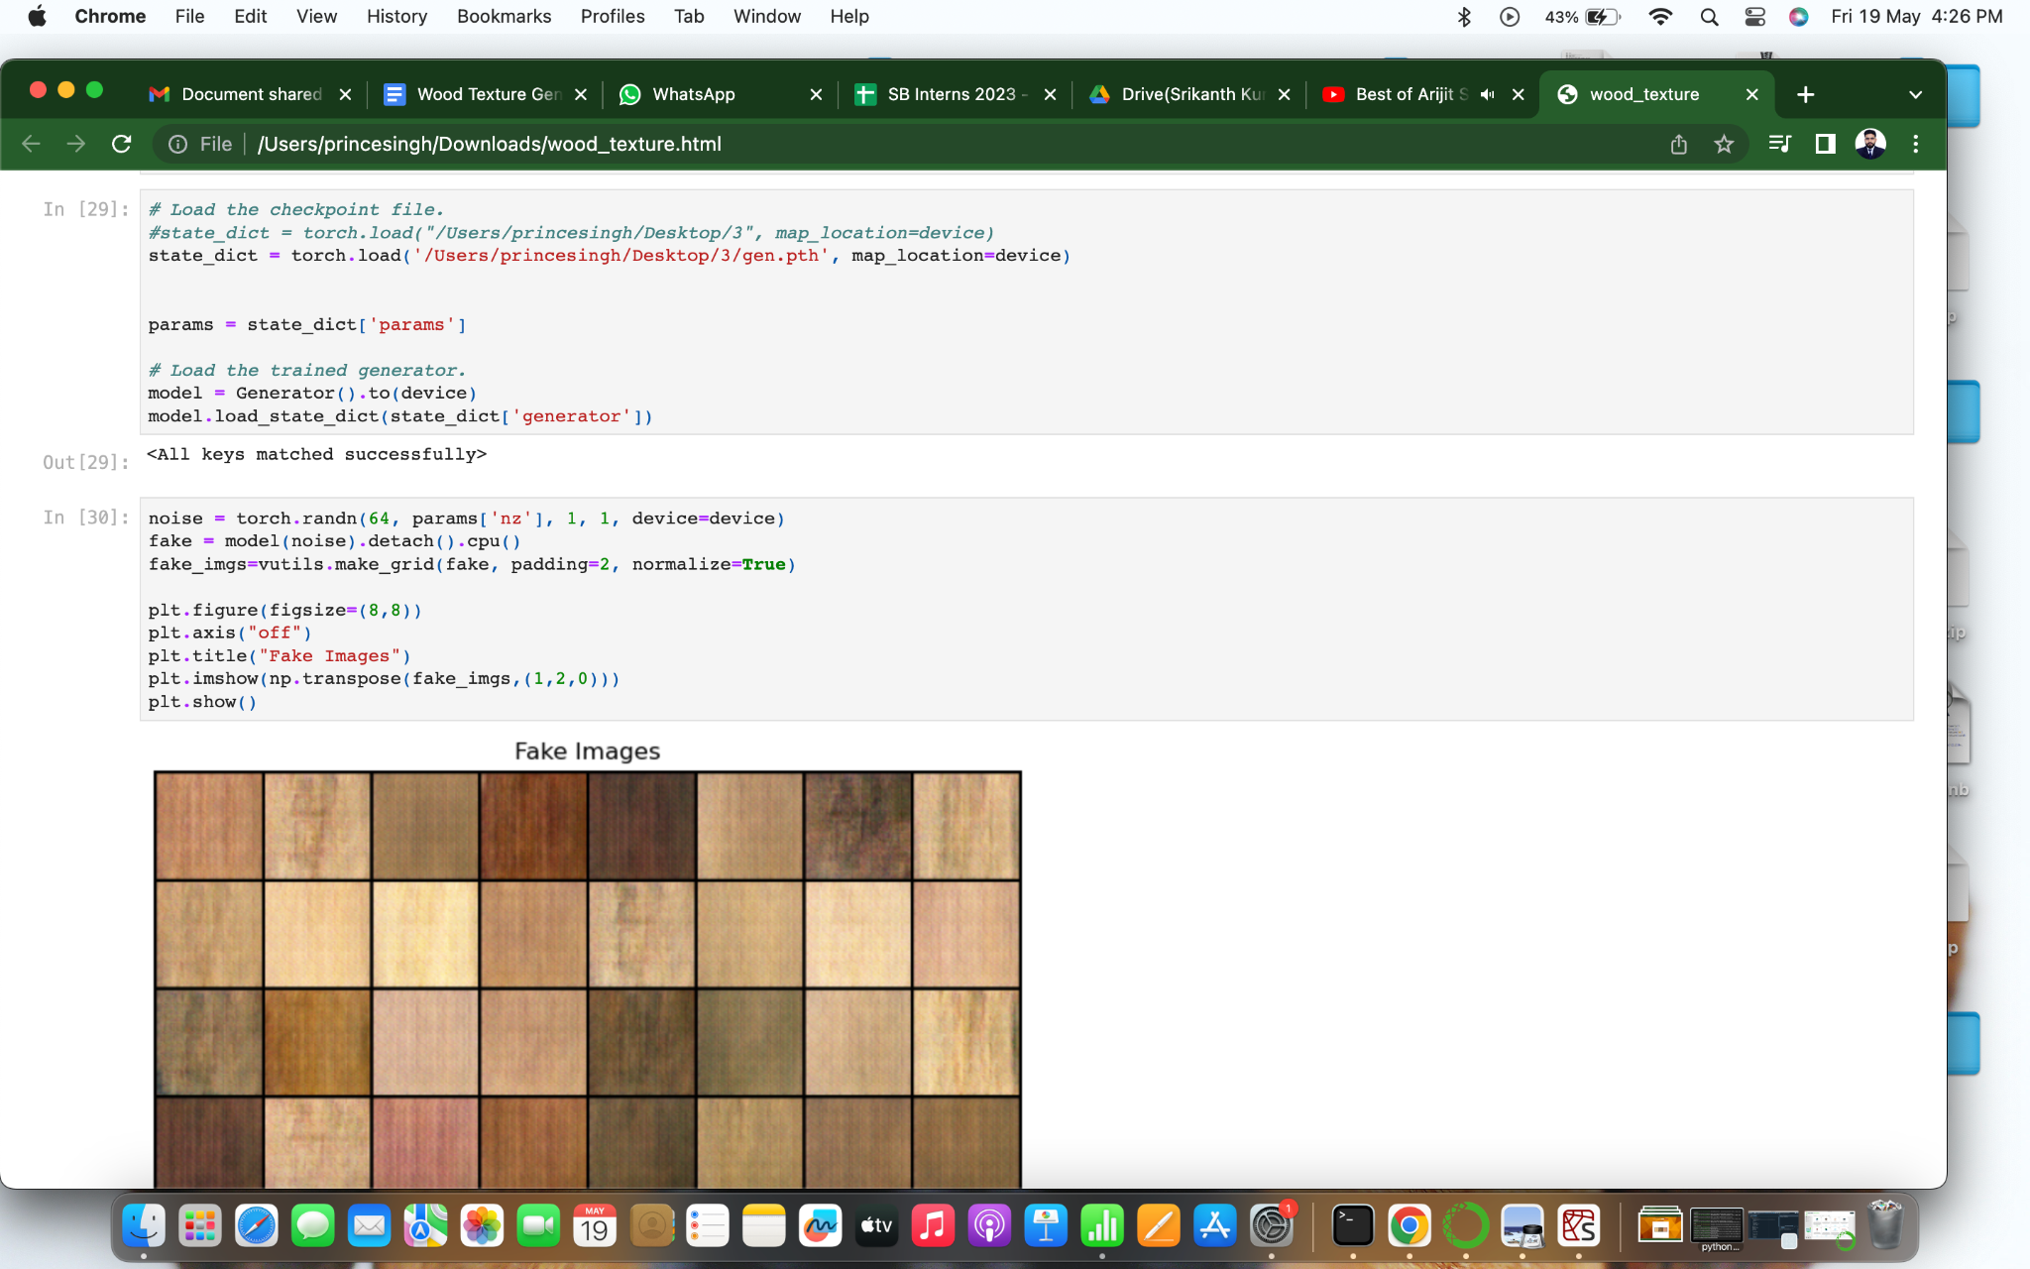

**Printing one sample using the saved model by calling it:**

The code starts by loading a checkpoint file that contains the trained model's state. The path to the checkpoint file is specified as "/Users/princesingh/Desktop/3/gen.pth". The "params" variable is extracted from the loaded state dictionary. It likely contains parameters related to the generator model. The code then creates an instance of the generator model called "model" and moves it to the appropriate device (e.g., GPU) if available. The generator model is assumed to be a custom implementation. The loaded state dictionary's "generator" key is used to load the trained weights into the generator model. A noise tensor is generated using torch.randn() function. This tensor is of size [64, params['nz'], 1, 1] and represents random input for the generator. The generator model is used to generate fake images by passing the noise tensor as input. The generated images are stored in the "fake" variable. The "fake" tensor is detached from the computation graph and transferred to the CPU for further processing. The "fake" tensor is converted into a grid of images using the vutils.make_grid() function. The "padding" parameter specifies the padding between the images, and the "normalize" parameter controls whether the images should be normalized. Finally, the generated grid of fake images is displayed using matplotlib.pyplot.imshow() function. The image grid is shown without axis labels, and the title of the plot is set to "Fake Images".

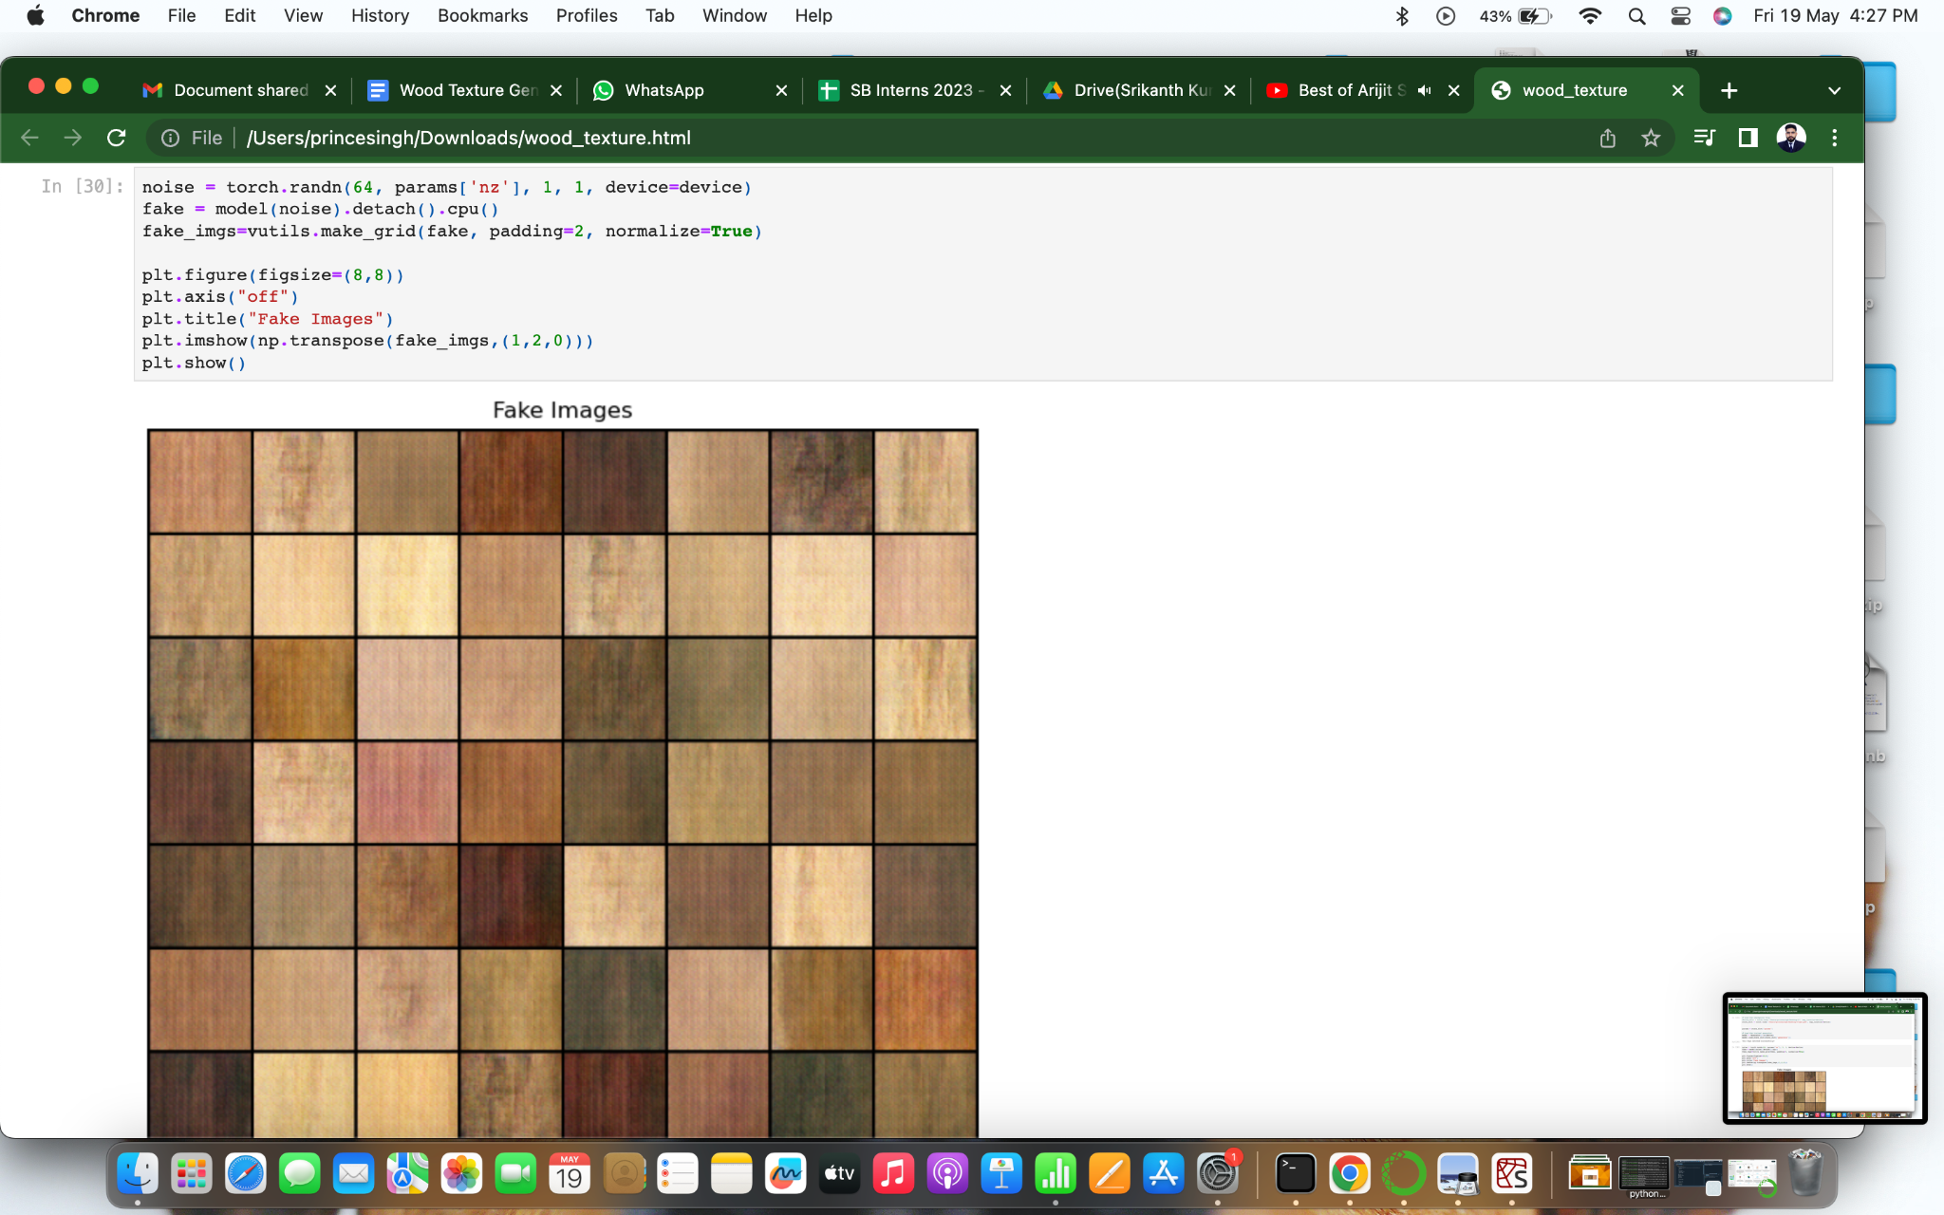

**Milestone 8: Application Building**

In this section, we will be building a web application that is integrated to the model we built. A UI is provided for the uses where he has to enter the values for predictions. The enter values are given to the saved model and prediction is showcased on the UI. This section has the following tasks

● Building HTML Pages

● Building server-side script

● Run the web application

**Activity 2.1: Building HTML pages:**

For this project we create two HTML files namely

• Index.html

And we will save them in the templates folder.

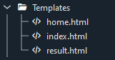

**Activity 2.2: Build Python code**

Create a new app.py file which will be stored in the Flask folder.

* Import the necessary Libraries.

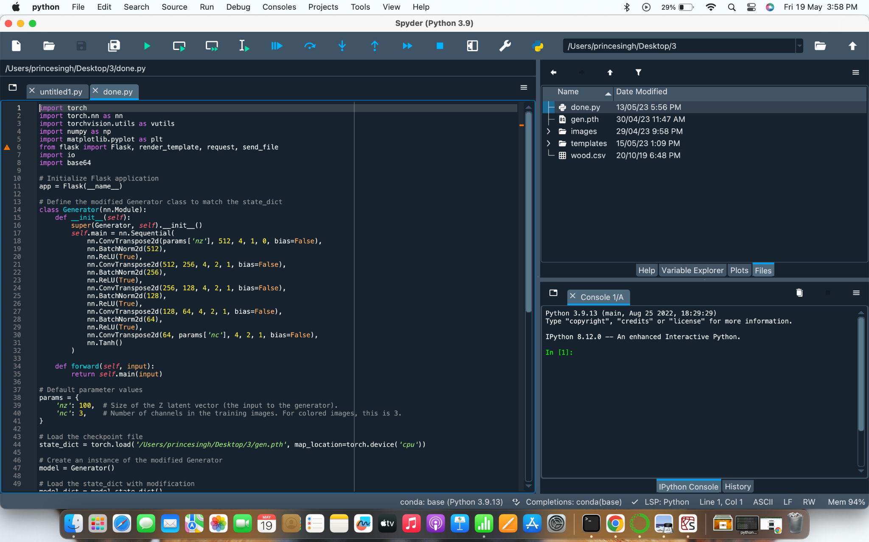

* This code loads a pre-trained machine learning model for wood texture generator, which has been saved in the file 'gen.pth’



* This code defines a function called generator which is combination of several deep learning layers which helps in generating distinct textures.



* It is part of preprocessing to define the parameters.



* Then i have loaded the static_dict with modifications and i have made ‘nz’ as a input feature to be taken from the client. Here nz is nothing but the number of patterns to be printed.

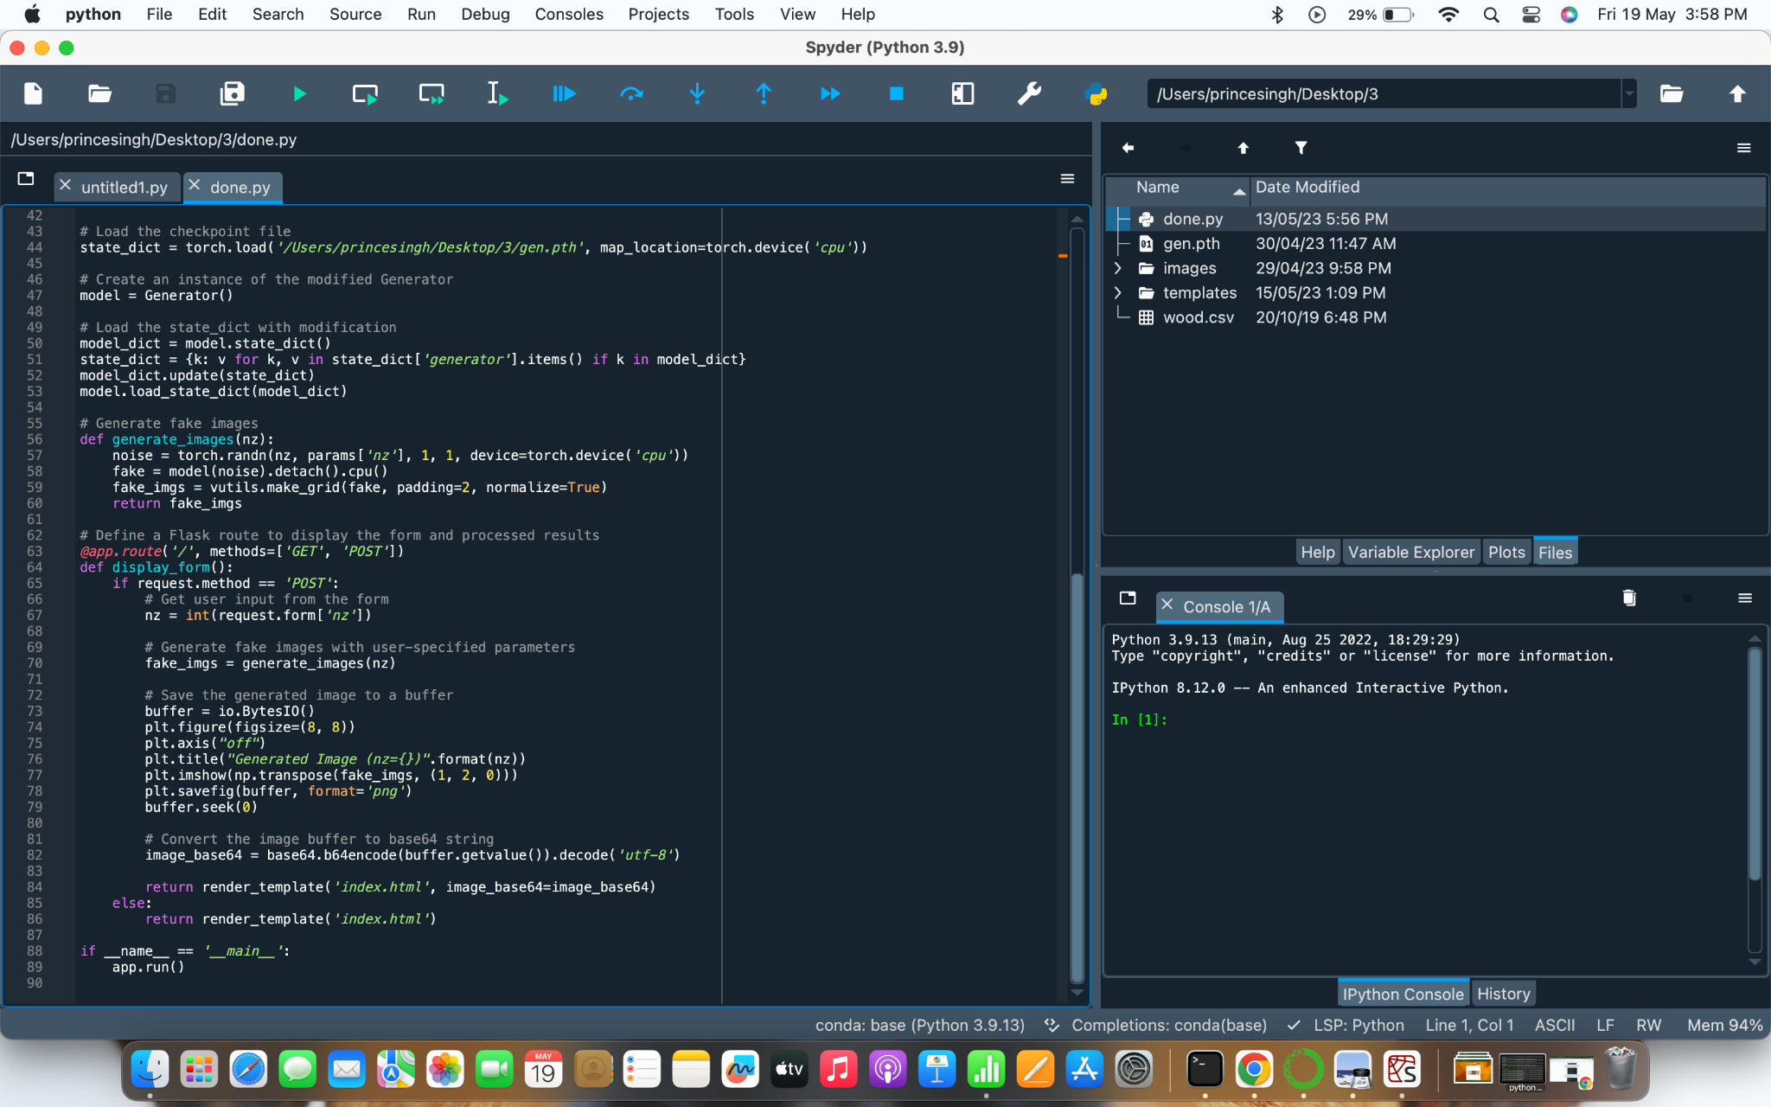

* This defines a route to the home page of the web application. When a user visits the base URL of the application (e.g. https://example.com/), Flask will execute the home() function and return the content of the home.html template. The render_template() function is used to render the HTML template, which can include dynamic content based on data passed to it from the Flask application.



* This code defines a route using Flask for the /predict URL. When a user navigates to this URL, the index() function is called, which renders an HTML template called index.html. This template likely contains a form for the user to upload an image to be classified.



template is rendered with the index class name and the path to the predicted image.

**Main Function:**

This code runs the Flask application if the script is being executed directly (i.e. not imported as a module in another script). The if __name__ == '__main__': line checks if the script is the main module being executed, and if so, runs the Flask application using the app.run() method. This method starts the Flask development server, allowing the application to be accessed via a web browser at the appropriate URL.

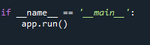

**Activity 2.3: Run the Web Application**

When you run the “app.py” file this window will open in the console or output terminal. Copy the URL given in the form http://127.0.0.1:5000 and paste it in the browser.

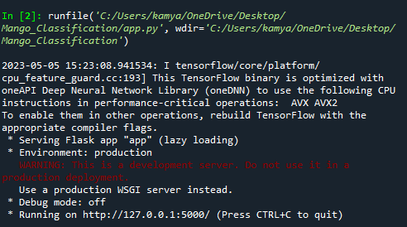

When we paste the URL in a web browser, our home.html page will open. It contains information about wood patterns and various varieties of it.

This is how our home page looks:

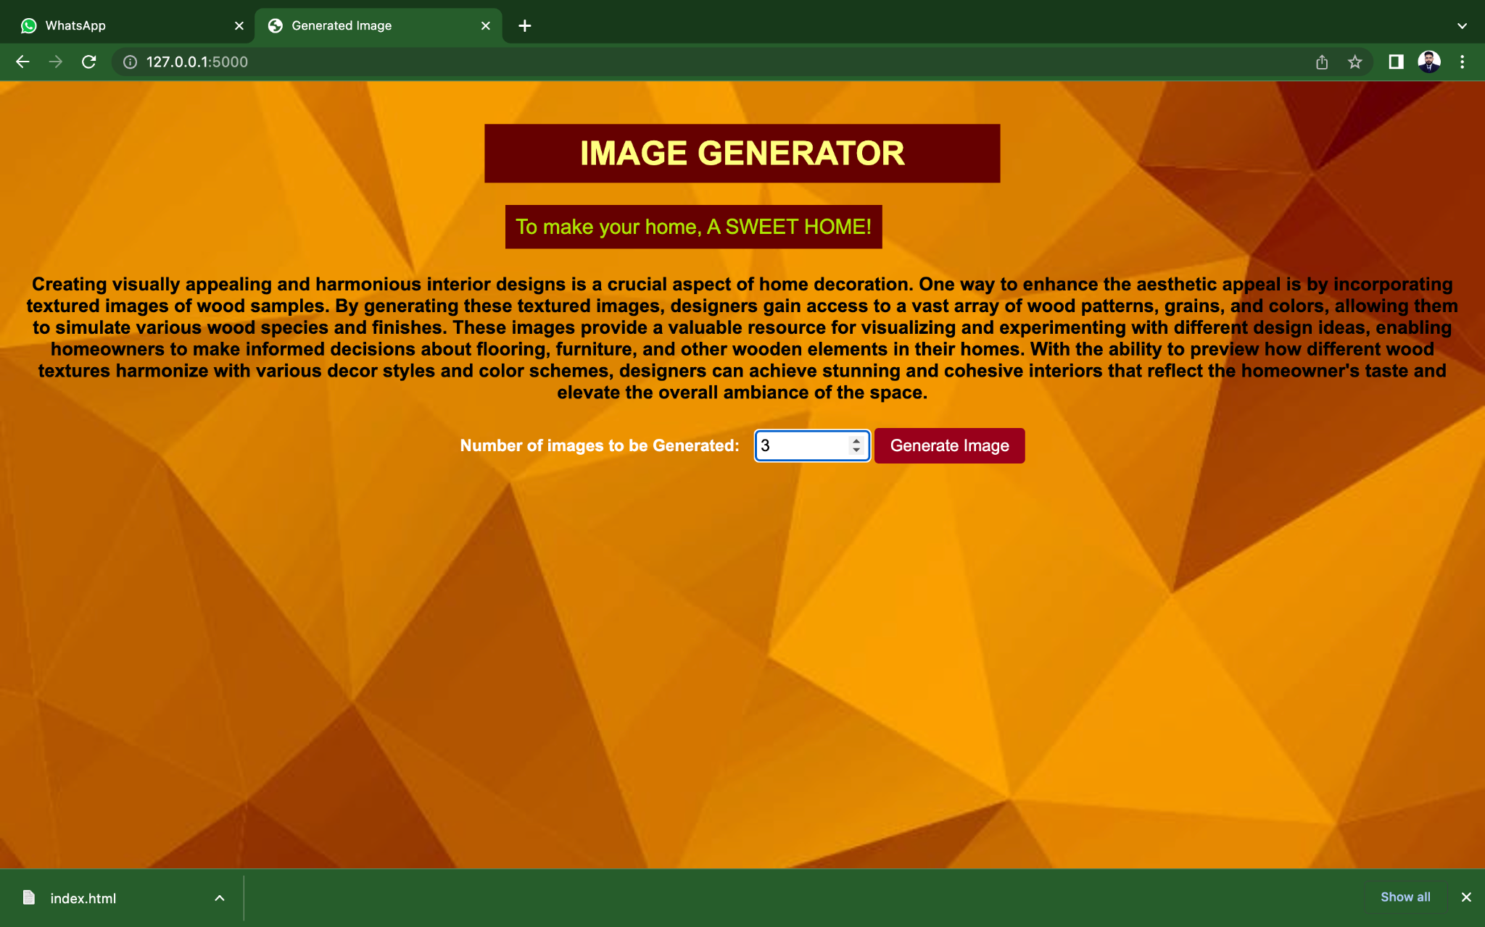

When i entered value as 3 as hit generated image it generated 3 textures as shown below:

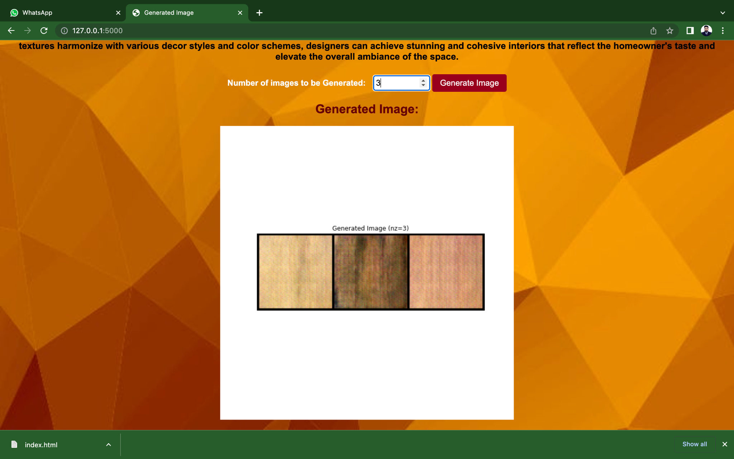

To generate more images of wood pattern,change the value of number of images.

**Link to GitHub Repository:**

https://github.com/PrinceSingh1198/wood-texture-generator